**ME119 Monsoon 2020: Sheet 7 Solutions**

1: Note: Dimensions are not known in this solution but students need to show dimensions in their drawing. TAs are advised to deduct marks if dimensions are not shown.

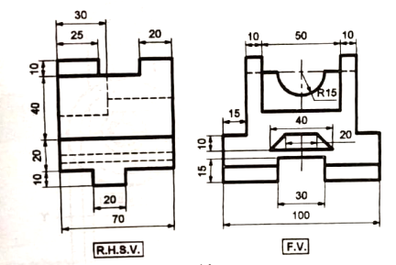

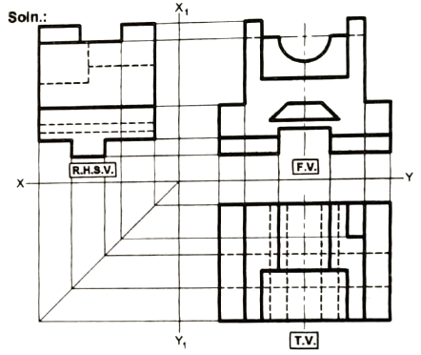

Problem 8

Note: Sectional TV is shown here but students are not required to draw sectional view. They are supposed to draw the uncut complete view. TAs please take this into account while grading.

